U25AI055
Lab-5
PART A: DOUBLY LINKED LIST (ADVANCED)
- Reverse a Doubly Linked List Input: 10 ⇄ 20 ⇄ 30 ⇄ 40 ⇄ NULL Output: Reversed Doubly Linked List: 40 ⇄ 30 ⇄ 20 ⇄ 10 ⇄ NULL
// A. 1. Reverse a doubly linked list
#include <iostream>
using namespace std;
struct Node {
Node *previous;
int data;
Node *next;
};
void displayList(Node *head);
Node* reverseList(Node *head);
int main() {
Node *head, *newNode, *temp;
head = NULL;
int n;
cout << "Enter number of nodes: ";
cin >> n;
for (int i = 0; i < n; i++) {
newNode = new Node;
cout << "Enter element " << i + 1 << ": ";
cin >> newNode->data;
newNode->next = NULL;

if (head == NULL) {
head = newNode;
temp = newNode;
temp->previous = NULL;
} else {
newNode->previous = temp;
temp->next = newNode;
temp = newNode;
}
}
cout << "Elements of list before reversal are ";
displayList(head);
cout << endl;
head = reverseList(head);
cout << "Elements of list after reversal are ";
displayList(head);
cout << endl;
return 0;
}
void displayList(Node *head) {
Node *ptr;
ptr = head;
while (ptr != NULL) {
cout << ptr->data << "\t";
ptr = ptr->next;
}
}
Node* reverseList(Node *head) {
Node *ptr, *q, *p;
ptr = head;
q = p = NULL;
while (ptr != NULL) {
p = ptr;
ptr = ptr->next;
p->next = q;
p->previous = ptr;
q = p;
}
head = p;
return head;
}
Output:
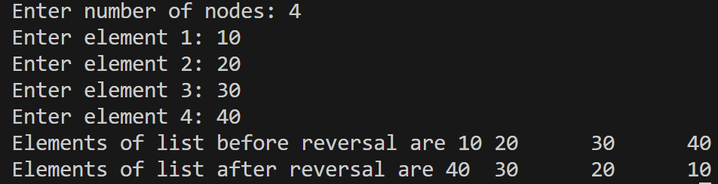
- Find Pair with Given Sum Input: List: 1 ⇄ 2 ⇄ 4 ⇄ 5 ⇄ 6 ⇄ 8 ⇄ 9 ⇄ NULL Sum = 7 Output: Pairs with given sum: (1, 6) (2, 5)
// A. 2. Find pair with given sum
#include <iostream>
#include <vector>
using namespace std;
struct Node {
Node *previous;
int data;
Node *next;
};
vector<vector<int>> findPair(Node *head, int target);
void displayList(Node *head);
int main() {
Node *head, *newNode, *temp;
int n, target;
head = NULL;
cout << "Enter number of nodes: ";
cin >> n;
for (int i = 0; i < n; i++) {
newNode = new Node;
cout << "Enter element " << i + 1 << ": ";
cin >> newNode->data;
newNode->next = NULL;

if (head == NULL) {
head = newNode;
temp = newNode;
temp->previous = NULL;
} else {
newNode->previous = temp;
temp->next = newNode;
temp = newNode;
}
}
displayList(head);
cout << endl;
cout << "Enter target: ";
cin >> target;
vector<vector<int>> result = findPair(head, target);
for (vector<int> pair : result) {
cout << "(" << pair[0] << ", " << pair[1] << ")\t";
}
cout << endl;
return 0;
}
void displayList(Node *head) {
Node *ptr;
ptr = head;
while (ptr != NULL) {
cout << ptr->data << "\t";
ptr = ptr->next;
}
}
vector<vector<int>> findPair(Node *head, int target) {
vector<vector<int>> result;
Node *p, *q;
q = head;
while (q->next != NULL) {
q = q->next;
}
p = head;
while (p != q && p->next != q) {
if (p->data + q->data == target) {
vector<int> pair{p->data, q->data};
result.push_back(pair);
p = p->next;
q = q->previous;
} else if (p->data + q->data > target) {
q = q->previous;
} else {
p = p->next;
}
}
return result;
}
Output:
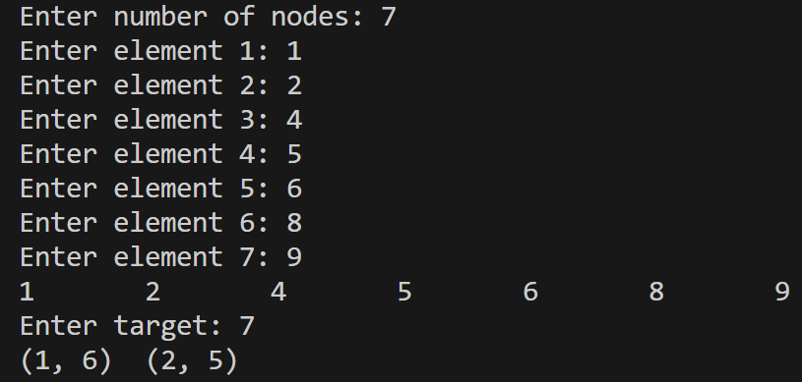
- Rotate by k Nodes Input: List: 10 ⇄ 20 ⇄ 30 ⇄ 40 ⇄ 50 ⇄ NULL k = 2 Output: List after rotation: 30 ⇄ 40 ⇄ 50 ⇄ 10 ⇄ 20 ⇄ NULL
// A. 3. Rotate by k nodes
#include <iostream>
using namespace std;
struct Node {
Node *previous;
int data;
Node *next;
};
void displayList(Node *head);
Node* rotateList(Node *head, int k);
int main() {
Node *head, *newNode, *temp;
int n, k;
head = NULL;
cout << "Enter number of nodes: ";
cin >> n;
for (int i = 0; i < n; i++) {
newNode = new Node;
cout << "Enter element " << i + 1 << ": ";
cin >> newNode->data;
newNode->next = NULL;
if (head == NULL) {
head = newNode;
temp = newNode;
temp->previous = NULL;
} else {
newNode->previous = temp;
temp->next = newNode;
temp = newNode;
}
}
cout << "Elements of list before rotation are ";
displayList(head);
cout << endl;
cout << "Enter k: ";
cin >> k;
head = rotateList(head, k);
cout << "Elements of list after rotation are ";
displayList(head);
cout << endl;
return 0;
}
void displayList(Node *head) {
Node *ptr;
ptr = head;
while (ptr != NULL) {
cout << ptr->data << "\t";
ptr = ptr->next;
}
}
Node* rotateList(Node *head, int k) {
if (head == NULL) {
return head;
}
Node *ptr, *p, *q;
int i;
q = head;
ptr = head;
for (i = 1; i < k && ptr->next != NULL; i++) {
ptr = ptr->next;
}
if (i == k) {
p = ptr->next;
ptr->next = NULL;
if (p != NULL) {
p->previous = NULL;
head = p;
p = head;
while (p->next != NULL) {
p = p->next;
}
p->next = q;
q->previous = p;
}
}
return head;
}
Output:
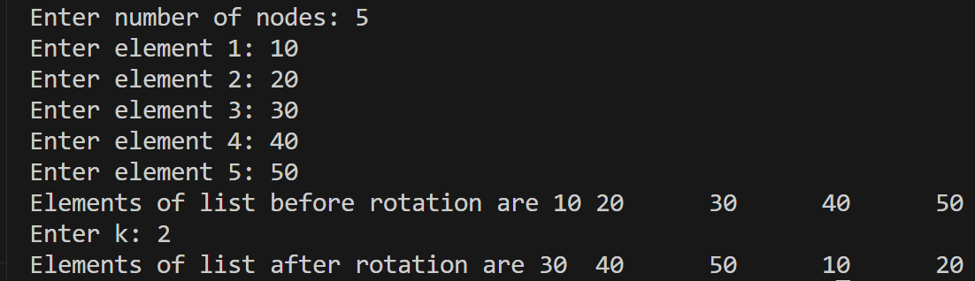
- Delete All Duplicate Nodes Input: 5 ⇄ 2 ⇄ 4 ⇄ 2 ⇄ 5 ⇄ 3 ⇄ NULL Output: List after removing all duplicates: 4 ⇄ 3 ⇄ NULL
// A. 4. Delete all duplicate nodes
#include <iostream>
using namespace std;
struct Node {
Node *previous;
int data;
Node *next;
};
void displayList(Node *head);
void removeElement(Node *head, Node *ptr);
Node* deleteAllDuplicates(Node *head);
int main() {
Node *head, *newNode, *temp;
int n, k;
head = NULL;
cout << "Enter number of nodes: ";
cin >> n;
for (int i = 0; i < n; i++) {
newNode = new Node;
cout << "Enter element " << i + 1 << ": ";
cin >> newNode->data;
newNode->next = NULL;
if (head == NULL) {
head = newNode;
temp = newNode;
temp->previous = NULL;
} else {
newNode->previous = temp;
temp->next = newNode;
temp = newNode;
}
}
head = deleteAllDuplicates(head);
displayList(head);
cout << endl;
return 0;
}
void displayList(Node *head) {
Node *ptr;
ptr = head;
while (ptr != NULL) {
cout << ptr->data << "\t";
ptr = ptr->next;
}
}
Node* deleteNode(Node *head, Node *ptr) {
if (ptr == head) {
if (ptr->next != NULL) {
ptr->next->previous = NULL;
}

head = ptr->next;

return head;
}

if (ptr->previous != NULL) {
ptr->previous->next = ptr->next;
}

if (ptr->next != NULL) {
ptr->next->previous = ptr->previous;
}
return head;
}
Node* deleteAllDuplicates(Node *head) {
Node *p, *q, *ptr, *temp;
int flag;
p = head;

while (p != NULL) {
q = p->next;
flag = 0;
while (q != NULL && flag == 0) {
if (p->data == q->data) {
flag = 1;
}
q = q->next;
}

if (flag == 1) {
ptr = head;
while (ptr != NULL) {
if (ptr->data == p->data) {
temp = ptr->next;
head = deleteNode(head, ptr);
ptr = temp;
} else {
ptr = ptr->next;
}
}
p = head;
} else {
p = p->next;
}

}
return head;
}
Output:
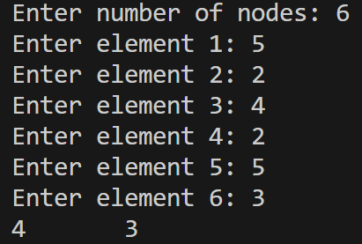
- Maximum Sum Sublist Input: 2 ⇄ -4 ⇄ 6 ⇄ -3 ⇄ 9 ⇄ -8 ⇄ NULL Output: Maximum sum sublist: 6 ⇄ -3 ⇄ 9 Maximum Sum = 12
// A. 5. Maximum sum sublist
#include <iostream>
using namespace std;
struct Node {
Node *previous;
int data;
Node *next;
};
void displayList(Node *head);
void displayList(Node *beg, Node *end);
int maximumSumSublist(Node *head);
int main() {
Node *head, *newNode, *temp;
int n, a, b;
head = NULL;
cout << "Enter number of nodes: ";
cin >> n;
for (int i = 0; i < n; i++) {
newNode = new Node;
cout << "Enter element " << i + 1 << ": ";
cin >> newNode->data;
newNode->next = NULL;

if (head == NULL) {
head = newNode;
temp = newNode;
temp->previous = NULL;
} else {
newNode->previous = temp;
temp->next = newNode;
temp = newNode;
}
}
displayList(head);
cout << endl;
cout << maximumSumSublist(head);
return 0;
}
void displayList(Node *head) {
Node *ptr;
ptr = head;
while (ptr != NULL) {
cout << ptr->data << "\t";
ptr = ptr->next;
}
}
void displayList(Node *beg, Node *end) {
Node *ptr;
ptr = beg;
while (ptr != NULL && ptr != end->next) {
cout << ptr->data << "\t";
ptr = ptr->next;
}
}
int maximumSumSublist(Node *head) {
Node *ptr, *beg, *end, *temp;
int result = 0, sum = 0;

ptr = head;

beg = head;
end = head;
temp = head;

while (ptr != NULL) {
sum += ptr->data;

if (sum > result) {
result = sum;
beg = temp;
end = ptr;
}

if (sum < 0) {
sum = 0;
temp = ptr->next;
}

ptr = ptr->next;
}

displayList(beg, end);
cout << endl;

return result;
}
Output:
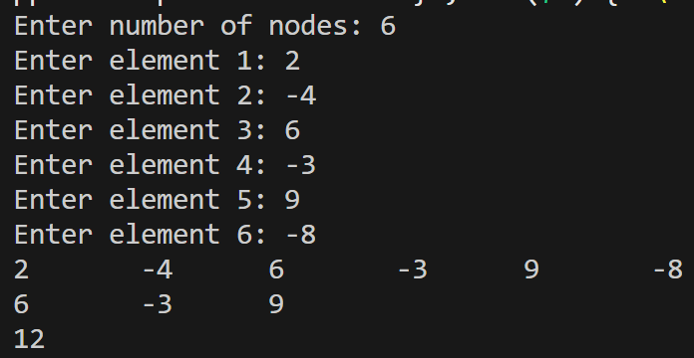
- Palindrome Check Input: 1 ⇄ 2 ⇄ 3 ⇄ 2 ⇄ 1 ⇄ NULL Output: The doubly linked list is a PALINDROME.
// A. 6. Palindrome check
#include <iostream>
using namespace std;
struct Node {
Node *previous;
int data;
Node *next;
};
void displayList(Node *head);
bool checkPalindrome(Node *head);
int main() {
Node *head, *newNode, *temp;
int n, k;
head = NULL;
cout << "Enter number of nodes: ";
cin >> n;
for (int i = 0; i < n; i++) {
newNode = new Node;
cout << "Enter element " << i + 1 << ": ";
cin >> newNode->data;
newNode->next = NULL;

if (head == NULL) {
head = newNode;
temp = newNode;
temp->previous = NULL;
} else {
newNode->previous = temp;
temp->next = newNode;
temp = newNode;
}
}
displayList(head);
cout << endl;
if (checkPalindrome(head)) {
cout << "Palindrome\n";
} else {
cout << "Not palindrome\n";
}
return 0;
}
void displayList(Node *head) {
Node *ptr;
ptr = head;
while (ptr != NULL) {
cout << ptr->data << "\t";
ptr = ptr->next;
}
}
bool checkPalindrome(Node *head) {
Node *p, *q;
q = head;
while (q->next != NULL) {
q = q->next;
}
p = head;
while (p->next != q && p != q) {
if (p->data != q->data) {
return false;
}
p = p->next;
q = q->previous;
}
return true;
}
Output:
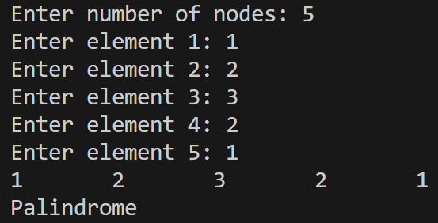
- Merge Two Sorted Doubly Linked Lists Input: List1: 1 ⇄ 3 ⇄ 5 ⇄ NULL List2: 2 ⇄ 4 ⇄ 6 ⇄ NULL Output: Merged Sorted Doubly Linked List: 1 ⇄ 2 ⇄ 3 ⇄ 4 ⇄ 5 ⇄ 6 ⇄ NULL
// 7. Merge two sorted doubly linked lists
#include <iostream>
using namespace std;
struct Node {
Node *previous;
int data;
Node *next;
};
void displayList(Node *head);
Node* mergeLists(Node *head1, Node *head2);
int main() {
Node *head, *head1, *head2, *newNode, *temp;
int n;
head1 = NULL;
cout << "Enter number of nodes: ";
cin >> n;
for (int i = 0; i < n; i++) {
newNode = new Node;
cout << "Enter element " << i + 1 << ": ";
cin >> newNode->data;
newNode->next = NULL;
if (head1 == NULL) {
head1 = newNode;
temp = newNode;
temp->previous = NULL;
} else {
newNode->previous = temp;
temp->next = newNode;
temp = newNode;
}
}
head2 = NULL;
cout << "Enter number of nodes: ";
cin >> n;
for (int i = 0; i < n; i++) {
newNode = new Node;
cout << "Enter element " << i + 1 << ": ";
cin >> newNode->data;
newNode->next = NULL;
if (head2 == NULL) {
head2 = newNode;
temp = newNode;
temp->previous = NULL;
} else {
newNode->previous = temp;
temp->next = newNode;
temp = newNode;
}
}
displayList(head1);
cout << endl;
displayList(head2);
cout << endl;
head = mergeLists(head1, head2);
displayList(head);
return 0;
}
void displayList(Node *head) {
Node *ptr;
ptr = head;
while (ptr != NULL) {
cout << ptr->data << "\t";
ptr = ptr->next;
}
}
Node* mergeLists(Node *head1, Node *head2) {
if (head1 == NULL) {
return head2;
} else if (head2 == NULL) {
return head1;
}
Node *head, *ptr, *p, *q;
p = head1;
q = head2;
if (p->data <= q->data) {
ptr = p;
p = p->next;
} else {
ptr = q;
q = q->next;
}
head = ptr;
while (p != NULL && q != NULL) {
if (p->data <= q->data) {
ptr->next = p;
p->previous = ptr;
p = p->next;
} else {
ptr->next = q;
q->previous = ptr;
q = q->next;
}
ptr = ptr->next;
}
if (p != NULL) {
ptr->next = p;
p->previous = ptr;
} else if (q != NULL) {
ptr->next = q;
q->previous = ptr;
}
return head;
}
Output:
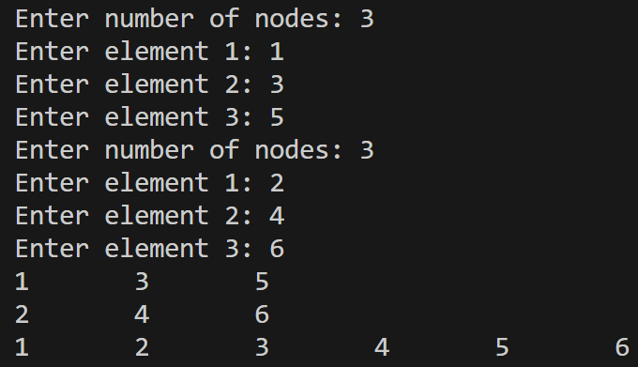
- Swap Nodes at Given Positions Input: List: 10 ⇄ 20 ⇄ 30 ⇄ 40 ⇄ NULL Swap positions 2 and 4 Output: List after swapping nodes: 10 ⇄ 40 ⇄ 30 ⇄ 20 ⇄ NULL
// A. 8. Swap nodes at given positions
#include <iostream>
using namespace std;
struct Node {
Node *previous;
int data;
Node *next;
};
void displayList(Node *head);
Node* swapNodes(Node *head, int a, int b);
int main() {
Node *head, *newNode, *temp;
int n, a, b;
head = NULL;
cout << "Enter number of nodes: ";
cin >> n;
for (int i = 0; i < n; i++) {
newNode = new Node;
cout << "Enter element " << i + 1 << ": ";
cin >> newNode->data;
newNode->next = NULL;

if (head == NULL) {
head = newNode;
temp = newNode;
temp->previous = NULL;
} else {
newNode->previous = temp;
temp->next = newNode;
temp = newNode;
}
}
displayList(head);
cout << endl;
cout << "Enter positions: ";
cin >> a >> b;
head = swapNodes(head, a, b);
displayList(head);
cout << endl;
return 0;
}
void displayList(Node *head) {
Node *ptr;
ptr = head;
while (ptr != NULL) {
cout << ptr->data << "\t";
ptr = ptr->next;
}
}
Node* swapNodes(Node *head, int a, int b) {
Node *p, *q, *pPrevious, *qPrevious, *pNext, *qNext;
p = head;
for (int i = 1; i < a && p != NULL; i++) {
p = p->next;
}
q = head;
for (int i = 1; i < b && q != NULL; i++) {
q = q->next;
}

pPrevious = p->previous;
pNext = p->next;
qPrevious = q->previous;
qNext = q->next;

if (p->next == q) {
if (p == head) {
head = q;
}
if (p->previous != NULL) {
p->previous->next = q;
}

if (q->next != NULL) {
q->next->previous = p;
}

q->previous = pPrevious;
q->next = p;

p->previous = q;
p->next = qNext;
} else {
if (p == head) {
head = q;
}

if (p->previous != NULL) {
p->previous->next = q;
}

if (p->next != NULL) {
p->next->previous = q;
}

if (q->previous != NULL) {
q->previous->next = p;
}

if (q->next != NULL) {
q->next->previous = p;
}

p->previous = qPrevious;
p->next = qNext;

q->previous = pPrevious;
q->next = pNext;
}
return head;
}
Output:
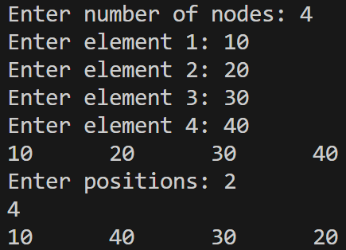
- Clone a Doubly Linked List with Random Pointer Output: Original and cloned lists are identical. Random pointers copied successfully
// A. 9. Clone doubly linked list with random pointers
#include <iostream>
using namespace std;
struct Node {
Node *previous;
int data;
Node *next;
Node *random;
};
void displayList(Node *head);
Node* cloneList(Node *head);
int main() {
Node *head, *node1, *node2, *node3, *node4;
node1 = new Node;
node2 = new Node;
node3 = new Node;
node4 = new Node;

head = node1;

node1->data = 1;
node1->next = node2;
node1->previous = NULL;
node1->random = node3;

node2->data = 3;
node2->next = node3;
node2->previous = node1;
node2->random = node3;

node3->data = 5;
node3->next = node4;
node3->previous = node2;
node3->random = NULL;

node4->data = 9;
node4->next = NULL;
node4->previous = node3;
node4->random = node3;

Node *clone = cloneList(head);
cout << "List cloned";
return 0;
}
void displayList(Node *head) {
Node *ptr;
ptr = head;
while (ptr != NULL) {
cout << ptr->data << "\t";
ptr = ptr->next;
}
}
Node* cloneList(Node *head) {
Node *clone, *newNode, *temp, *originalNext, *duplicateNext, *duplicate, *original;

clone = NULL;
original = head;

while (original != NULL) {
newNode = new Node;
newNode->data = original->data;
newNode->next = NULL;
newNode->previous = NULL;
if (clone == NULL) {
clone = newNode;
temp = newNode;
} else {
newNode->previous = temp;
temp->next = newNode;
temp = newNode;
}
original = original->next;
}

duplicate = clone;
original = head;

while (duplicate != NULL)
{
originalNext = original->next;

original->next = duplicate;
duplicate->previous = original;

duplicateNext = duplicate->next;

duplicate->next = originalNext;

if (originalNext != NULL) {
originalNext->previous = duplicate;
}

original = originalNext;
duplicate = duplicateNext;
}

original = head;

while (original != NULL && original->next != NULL) {
if (original->random != NULL) {
original->next->random = original->random->next;
}
original = original->next->next;
}

original = head;
duplicate = head->next;

while (original != NULL) {
originalNext = original->next;
original->next = originalNext->next;

if (original->next != NULL) {
original->next->previous = original;
}

if (duplicate->next != NULL) {
duplicate->next = duplicate->next->next;

if (duplicate->next != NULL) {
duplicate->next->previous = duplicate;
}
}

original = original->next;
duplicate = duplicate->next;
}
return clone;
}
Output:
PART B: CIRCULAR LINKED LIST (ADVANCED)
- Split Circular Linked List Input: 10 → 20 → 30 → 40 → 50 → 60 → (back to 10) Output: First Half: 10 → 20 → 30 → (back to 10) Second Half: 40 → 50 → 60 → (back to 40)
// B. 1. Split circular linked list
#include <iostream>
using namespace std;
struct Node {
int data;
Node *next;
};
void displayList(Node *head);
void splitList(Node *head);
int main() {
int n;
Node *head, *newNode, *temp;

head = NULL;

cout << "Enter number of nodes: ";
cin >> n;

for (int i = 0; i < n; i++) {
newNode = new Node;

cout << "Enter element " << i + 1 << ": ";
cin >> newNode->data;

newNode->next = head;

if (head == NULL) {
head = newNode;
temp = newNode;
} else {
temp->next = newNode;
temp = newNode;
}
}

displayList(head);
cout << endl;

splitList(head);
return 0;
}
void displayList(Node *head) {
Node *ptr;

ptr = head;

do
{
cout << ptr->data << "\t";
ptr = ptr->next;
} while (ptr != head);
}

void splitList(Node *head) {
Node *slow, *fast, *another, *ptr;

slow = head;
fast = head;

do {
slow = slow->next;
fast = fast->next->next;
} while (fast != head && fast->next != head);

ptr = head;

while (ptr->next != slow) {
ptr = ptr->next;
}

ptr->next = head;

another = slow;

ptr = another;

while (ptr->next != head) {
ptr = ptr->next;
}

ptr->next = another;

displayList(head);
cout << endl;
displayList(another);
cout << endl;
}
Output:
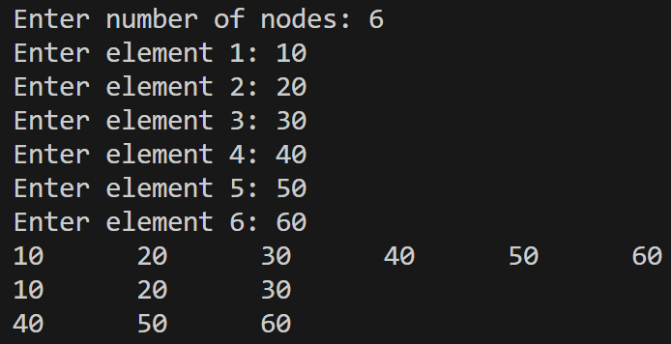
- Check if Circular List is Sorted Input: 1 → 3 → 5 → 7 → (back to 1) Output: The circular linked list is SORTED.
// B. 2. Check is circular list is sorted
#include <iostream>
using namespace std;
struct Node {
int data;
Node *next;
};
void displayList(Node *head);
bool checkSortedList(Node *head);
int main() {
int n;
Node *head, *newNode, *temp;

head = NULL;

cout << "Enter number of nodes: ";
cin >> n;

for (int i = 0; i < n; i++) {
newNode = new Node;

cout << "Enter element " << i + 1 << ": ";
cin >> newNode->data;

newNode->next = head;

if (head == NULL) {
head = newNode;
temp = newNode;
} else {
temp->next = newNode;
temp = newNode;
}
}

displayList(head);
cout << endl;

if (checkSortedList(head)) {
cout << "Sorted in ascending order\n";
} else {
cout << "Not sorted in ascending order\n";
}
return 0;
}
void displayList(Node *head) {
Node *ptr;

ptr = head;

do
{
cout << ptr->data << "\t";
ptr = ptr->next;
} while (ptr != head);
}
bool checkSortedList(Node *head) {
Node *ptr;
ptr = head;
do {
if (ptr->data > ptr->next->data) {
return false;
}
ptr = ptr->next;
} while (ptr->next != head);
return true;
}
Output:
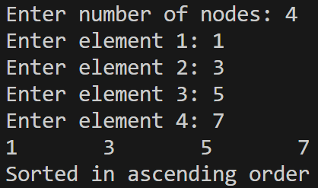
- Insert into Sorted Circular Linked List Input: Insert 6 into: 1 → 3 → 5 → 7 → (back to 1) Output: After insertion: 1 → 3 → 5 → 6 → 7 → (back to 1)
// B. 3. Insert into sorted circular linked list
#include <iostream>
using namespace std;
struct Node {
int data;
Node *next;
};
void displayList(Node *head);
Node *insertIntoSortedList(Node *head, int item);
int main() {
int n, item;
Node *head, *newNode, *temp;

head = NULL;

cout << "Enter number of nodes: ";
cin >> n;

for (int i = 0; i < n; i++) {
newNode = new Node;

cout << "Enter element " << i + 1 << ": ";
cin >> newNode->data;

newNode->next = head;

if (head == NULL) {
head = newNode;
temp = newNode;
} else {
temp->next = newNode;
temp = newNode;
}
}

displayList(head);
cout << endl;

cout << "Enter item: ";
cin >> item;

head = insertIntoSortedList(head, item);

displayList(head);
return 0;
}
void displayList(Node *head) {
Node *ptr;

ptr = head;

do
{
cout << ptr->data << "\t";
ptr = ptr->next;
} while (ptr != head);
}
Node *insertIntoSortedList(Node *head, int item) {
Node *ptr, *newNode;
newNode = new Node;
newNode->data = item;

if (head->data > item) {
newNode->next = head;

ptr = head;

while (ptr->next != head) {
ptr = ptr->next;
}
ptr->next = newNode;

head = newNode;
return head;
}

ptr = head;

do {
if (ptr->next->data > item) {

newNode->next = ptr->next;
ptr->next = newNode;

break;
}
ptr = ptr->next;
} while (ptr->next != head);

if (ptr->next == head) {
newNode->next = head;
ptr->next = newNode;
}
return head;
}
Output:
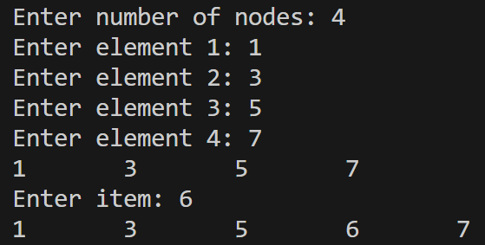
- Reverse Circular Linked List Input: 1 → 2 → 3 → 4 → (back to 1) Output: Reversed Circular Linked List: 4 → 3 → 2 → 1 → (back to 4)
// B. 5. Reverse circular linked list
#include <iostream>
using namespace std;
struct Node {
int data;
Node *next;
};
void displayList(Node *head);
Node* reverseList(Node *head);
int main() {
int n;
Node *head, *newNode, *temp;

head = NULL;

cout << "Enter number of nodes: ";
cin >> n;

for (int i = 0; i < n; i++) {
newNode = new Node;

cout << "Enter element " << i + 1 << ": ";
cin >> newNode->data;

newNode->next = head;

if (head == NULL) {
head = newNode;
temp = newNode;
} else {
temp->next = newNode;
temp = newNode;
}
}

displayList(head);
cout << endl;

head = reverseList(head);

displayList(head);
cout << endl;
return 0;
}
void displayList(Node *head) {
Node *ptr;

ptr = head;

do
{
cout << ptr->data << "\t";
ptr = ptr->next;
} while (ptr != head);
}
Node* reverseList(Node *head) {
Node *ptr, *slow, *fast;

ptr = head;
while (ptr->next != head) {
ptr = ptr->next;
}
ptr->next = NULL;

ptr = head;
slow = NULL;
fast = NULL;

while (ptr != NULL) {
fast = ptr;
ptr = ptr->next;
fast->next = slow;
slow = fast;
}

ptr = head;

while (ptr->next != NULL) {
ptr = ptr->next;
}

ptr->next = fast;

head = fast;

return head;
}
Output:
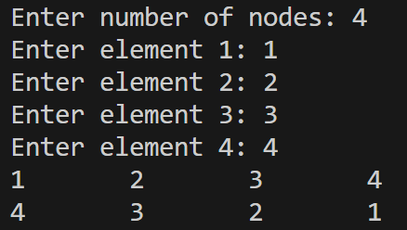
- Delete Every k-th Node Input: List: 1 → 2 → 3 → 4 → 5 → (back to 1) k = 2 Output: Remaining node: 3
// B. 5. Delete every kth node
#include <iostream>
using namespace std;
struct Node {
int data;
Node *next;
};
void displayList(Node *head);
Node *deleteEveryKthNode(Node *head, int k);
int main() {
int n;
Node *head, *newNode, *temp;

head = NULL;

cout << "Enter number of nodes: ";
cin >> n;

for (int i = 0; i < n; i++) {
newNode = new Node;

cout << "Enter element " << i + 1 << ": ";
cin >> newNode->data;

newNode->next = head;

if (head == NULL) {
head = newNode;
temp = newNode;
} else {
temp->next = newNode;
temp = newNode;
}
}

displayList(head);
cout << endl;

head = deleteEveryKthNode(head, 2);

displayList(head);
cout << endl;

return 0;
}
void displayList(Node *head) {
Node *ptr;

ptr = head;

do
{
cout << ptr->data << "\t";
ptr = ptr->next;
} while (ptr != head);
}
Node* deleteNode(Node *head, Node *ptr) {
Node *p;
if (ptr == head) {
p = head;
while (p->next != head) {
p = p->next;
}
p->next = ptr->next;
head = ptr->next;
delete ptr;
return head;
}

p = head;
while (p->next != ptr) {
p = p->next;
}
p->next = ptr->next;
delete ptr;
return head;
}
Node *deleteEveryKthNode(Node *head, int k) {
Node *ptr, *temp;
ptr = head;
while (ptr->next != ptr) {
for (int i = 1; i < k; i++) {
ptr = ptr->next;
}
temp = ptr->next;
head = deleteNode(head, ptr);
ptr = temp;

displayList(head);
cout << endl;
}
return head;
}
Output:
